**SOW**

**Statement Of Work**

Project Title

# Twenty Questions

Team Members

Caela Goins

Edwin Catalan

Quadre Jackson

Project Description

The goal of this group is to create an animal guessing game called ‘TBA’. The game begins with prompting the user to think of any animal. From there the game will ask a series of questions to determine what the animal may be based on user input of yes, no, or both. The game will be hosted on a webpage and use the mouse pad to gather user clicks as input. A database will store 100 animals and the game will access the database to determine possible guesses based on user responses. If the game guesses the user’s animal correctly an option to replay is given. Otherwise if the game fails to correctly guess the user’s animal after a number of wrong guesses, the user is prompted to type in their animal whereby it will be checked against the database and if not found the game will add the animal as a new entry to the database.

Scope

A user should be able to access the game using a given link. The user should not be given access to the database in terms of viewing or modifying animal entries. The database should have appropriate security features to prevent user access. The game should be able to avoid repetitive questions and not guess the same animal twice in one play session. The database linked to the game should contain 100 starting animals and be able to expand to accommodate new animal entries.

Scope Limitation

The database linked to the game will only contain 100 starting animals and will have a maximum size as there are billions of possible animals that are not able to be listed in the database. The game is limited to a certain number of wrong guesses and a list of generalized questions to narrow down possible answers to the user’s animal.

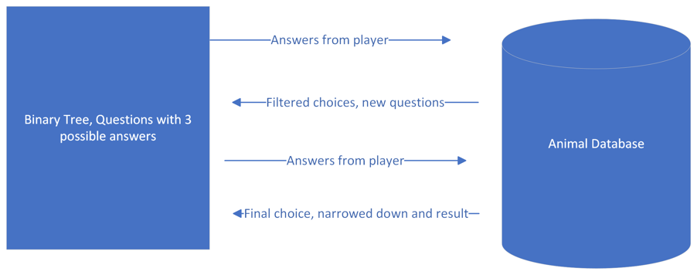

Stake Holders

Team Members

Period & Place

Project starts January 11, 2023 and ends the week of May 5, 2023. Most of the design, code, testing, and project documentation will be done on UNCP campus, but a portion of the project will be done through online collaboration and in-person meetings on-campus outside of scheduled class time.

Deliverables & Schedule:

1. SOW – 1/14/2023 [include dates for all)
2. WBS – 1/17/2023
3. SRS – TBA
4. SDD— TBA
5. Midterm-1 Program & Test Report - TBA
6. Midterm-2 Program & Test Report - TBA
7. Project Completion Report - TBA